|  |
| --- |
|  |

Impact of Road Closure Policy on Neighborhood

Davi Bicudo Guggisberg

Xiao Sun

ABMT Report

January 2019

Course Report, ABMT 2018 HS

Impact of Road Closure Policy on Neighborhood

Davi Bicudo Guggisberg, Xiao Sun

IVT ETH Zurich

Stefano-Franscini-Platz 5, 8093 Zurich, Switzerland

E-Mail: davig@student.ethz.ch

E-Mail: sunxi@student.ethz.ch

January 2019

Keywords

MATSim; Traffic Simulation; Transport Policy; Paris; Route Choice, Vehicle Behavior

Preferred citation style

Guggisberg, Davi Bicudo, Xiao, Sun (2019) Title, *Course Report*, **ABMT 2018HS**, IVT, ETH Zurich, Zurich.

Table of contents

1 Site Description 3

2 Scenarios 3

2.1 Baseline Scenario 3

2.2 “Link Closure” Scenario 4

2.3 “Flexible Departure” Scenario 4

3 General Settings 5

4 Outcome Analysis 5

4.1 Travelers (Agents) 5

4.2 Roads (Links) 8

4.3 Emission 11

5 Conclusion and Improvements 12

5.1 Conclusion 12

5.2 Limitations 12

5.3 Future Work 12

A References 13

# Site Description

The intended to be closed route is located at the center of Paris as shown in Figure 1 (left, showed in red line). Route is at the north side of Seine River from Place de la Concorde to Bassin de l’Aresenal and plays an important role in the city center. The policy to close those urban motorway vehicle lanes aim at improving the walking and cycling quality of this area.

Figure 1 (right) shows a typical traffic situation on a Monday morning at 9:00 peak hour. It can be seen that the west section of this route has a relatively slow traveling speed and indicates a possible traffic bottleneck. What kind of impact this policy will have on the neighborhoods and people using those roads stay unknown before the policy’s implementation.

In this report, we use MATSim to simulation scenarios under different settings to exam the possible influence of this policy on the neighborhoods nearby and people frequently using those routes.

Figure 1: Site Location and Site Typical Traffic Situation

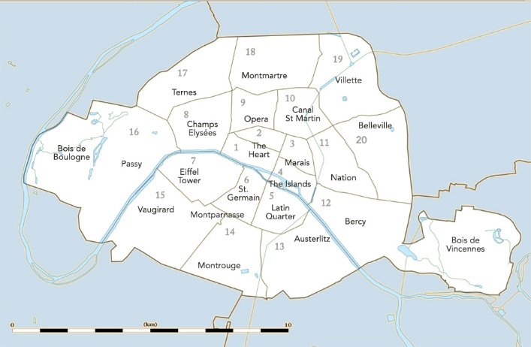 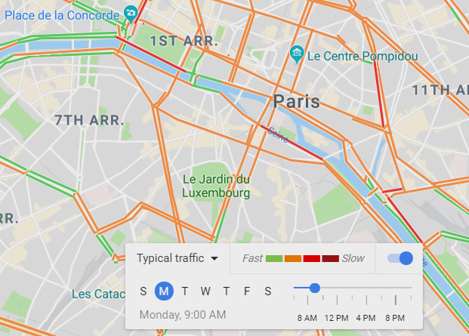

Source: (ParisInsidersGuide, 2019) , (GoogleMap, 2019)

# Scenarios

## Baseline Scenario

The Baseline Scenario simulates the car operation situation based on a synthetic population for the whole Ile de France region, to provide a reference for the future evaluation of road closure policy.

## “Link Closure” Scenario

The “Link Closure” Scenario creates a modified network, where the intended closed roads are disabled for cars. Travelers thus have the option to modify their route choice to find the route to reach destinations with the highest utility. This scenario analyses the impact of road-closure policy if travelers don’t want to risk being late or increase travel cost due to earlier arrival.

## “Flexible Departure” Scenario

The “Flexible Departure” Scenario allows for travelers’ departure time modification within 30 minutes based on “Link Closure” Scenario. It analyses how peoples’ travel time decision would change if certain roads are disabled.

# General Settings

Iterations times of all 3 scenarios are set to be 100 to simulate travelers’ behaviors as close as to what might happen in the reality.

To disable and close the roads, the capacity of all relevant links is set to 0. In addition, all other roads that would become a dead-end road due to road closure policy are also closed to run the simulation smoothly. Roads to be closed are shown in Figure 2.

Allowed departure time modification for agents is within 30 minutes which is closer to people’s behavior.

Figure 2: Intended Closed Roads and Dead-end Roads

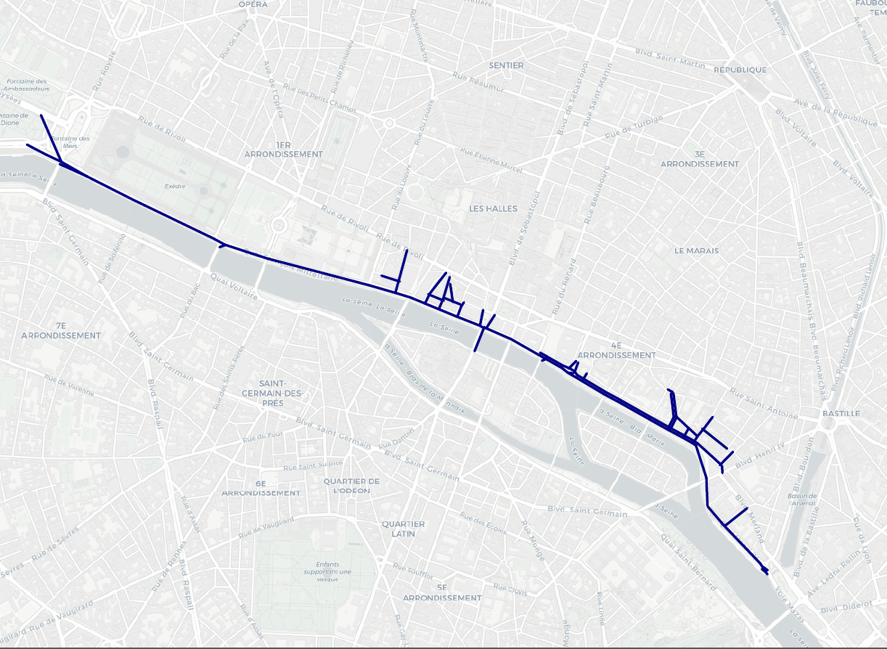

Source: Author

# Outcome Analysis

## Travelers (Agents)

In this section, agents with activities on the closed roads are analyzed.

As shown in Figure 3 and Figure 4, travelers’ travel time under baseline scenario stays the shortest among three. Morning peak hour travel time is shorter than that in the afternoon. One possible explanation is that people tend to have more leisure activities which might contribute to a longer travel distance.

It’s notable that at morning peak a flexible departure time contributes to a longer travel time while at evening peak hours, a flexible departure time decreases the travel time. One possible explanation is that travelers who used to travel later than 8 a.m. or earlier than 7 a.m. after the policy implementation shift their travel time, and thus increase the total travel time in this hour. To exam this, travel time distribution from 6 a.m. to 7 a.m. as well as 8 a.m. to 9 a.m. should also be examined.

Figure 3: Travelers’ Travel Time Distribution under 3 Scenarios (Morning Peak)

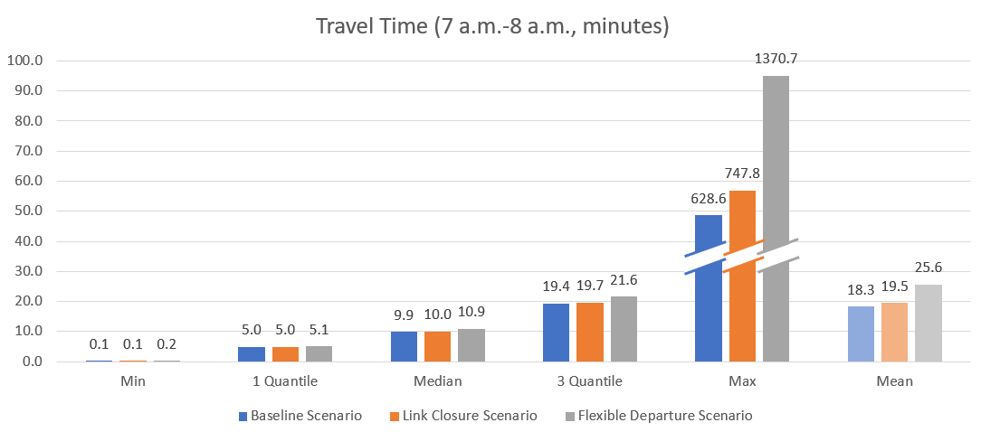

Source: Author

Figure 4: Travelers’ Travel Time Distribution under 3 Scenarios (Afternoon Peak)

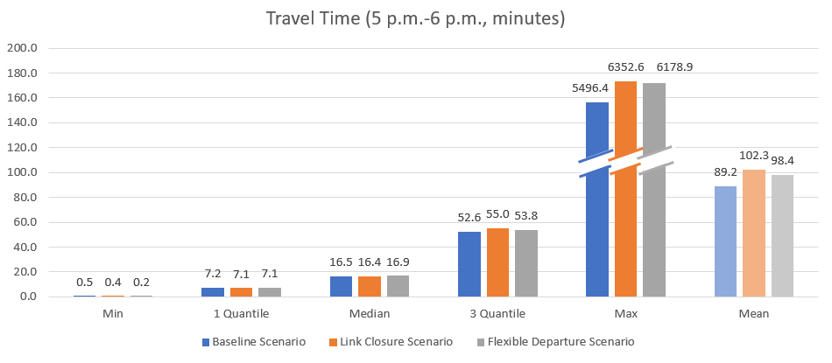

Source: Author

The scores of agents under each scenario are shown in Figure 5 (dashed lines are average scores) and Table 1.

In all 3 scenarios scores concentrates at the range of 0 to – 150, while some agents’ scores are lower than -400. Compared with Baseline Scenario, both “Road Closure” and “Flexible Departure” Scenarios have lower average scores, which indicates the car drivers’ utility is worsened off due to this policy. Under “Flexible Departure” Scenario, more agents get a score higher than -50 than “Road Closure” Scenarios and the highest score has improved a lot, but the average score is lower, while the lowest score is also worsened off. It’s attributable that while some agents are trying to adjust their departure time to get a higher utility, they also generate negative externalities on other agents.

Table 1: Average Score of Agents under 3 Scenarios

|  |  |  |  |
| --- | --- | --- | --- |
| Scenarios | Baseline | “Road Closure” | “Flexible Departure” |
| Highest | -2.32 | -2.58 | -0.60 |
| Average | -48.31 | -63.82 | -66.14 |
| Lowest | -559.21 | -540.14 | -562.55 |
| Source: Author | | | |

Figure 5: Travelers’ Score under 3 Scenarios

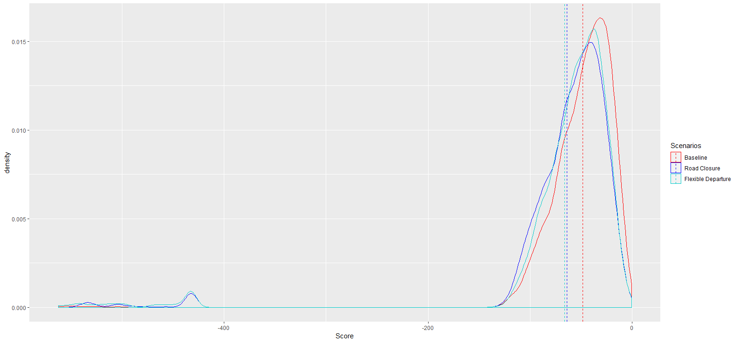

Source: Author

## Roads (Links)

In this section, links within a 1 km buffer area of closed roads are analyzed, since they represent the most directly effect of this policy around the area.

The volume and speed on the roads under 3 Scenarios are shown in Figure 6, Figure 7, and Figure 8. Relative lower speed on the route to be closed can be observed in Baseline Scenario. After the implementation of the policy, the traffic volume change is not clear to be observed from maps. Thus, a detailed analysis is carried out in the next paragraph.

Figure 6: Traffic Volume Visualization under Baseline Scenario

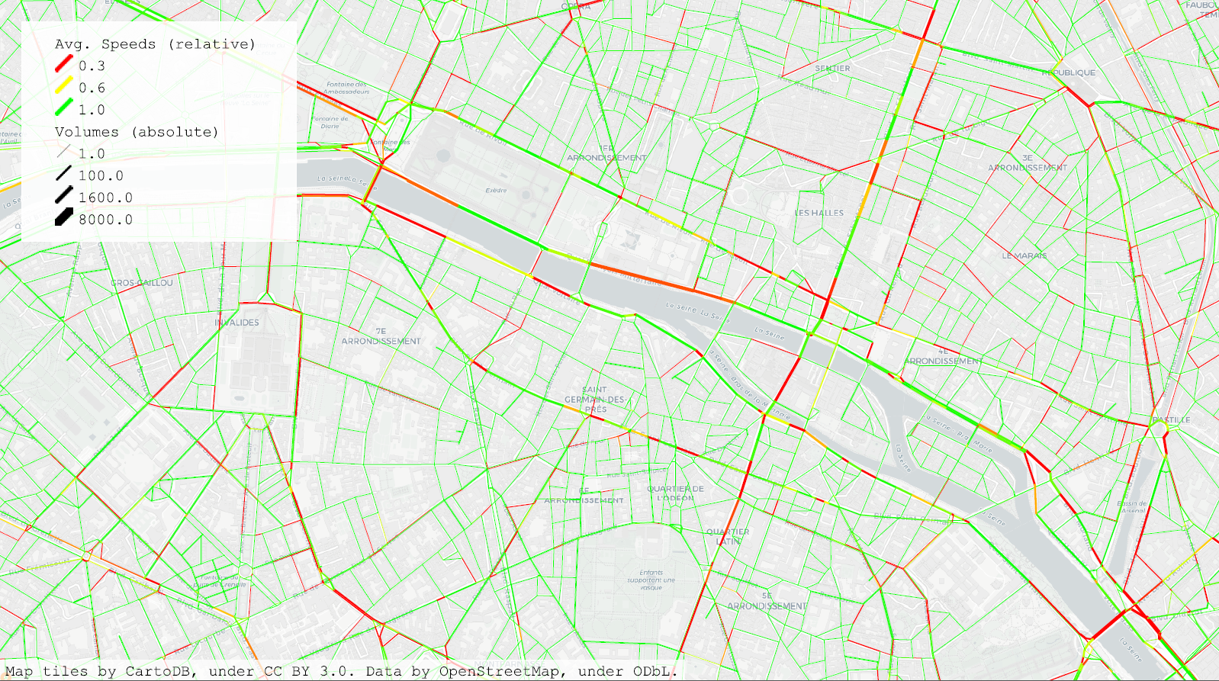

Source: Author

Figure 7: Traffic Volume Visualization under “Link Closure” Scenario

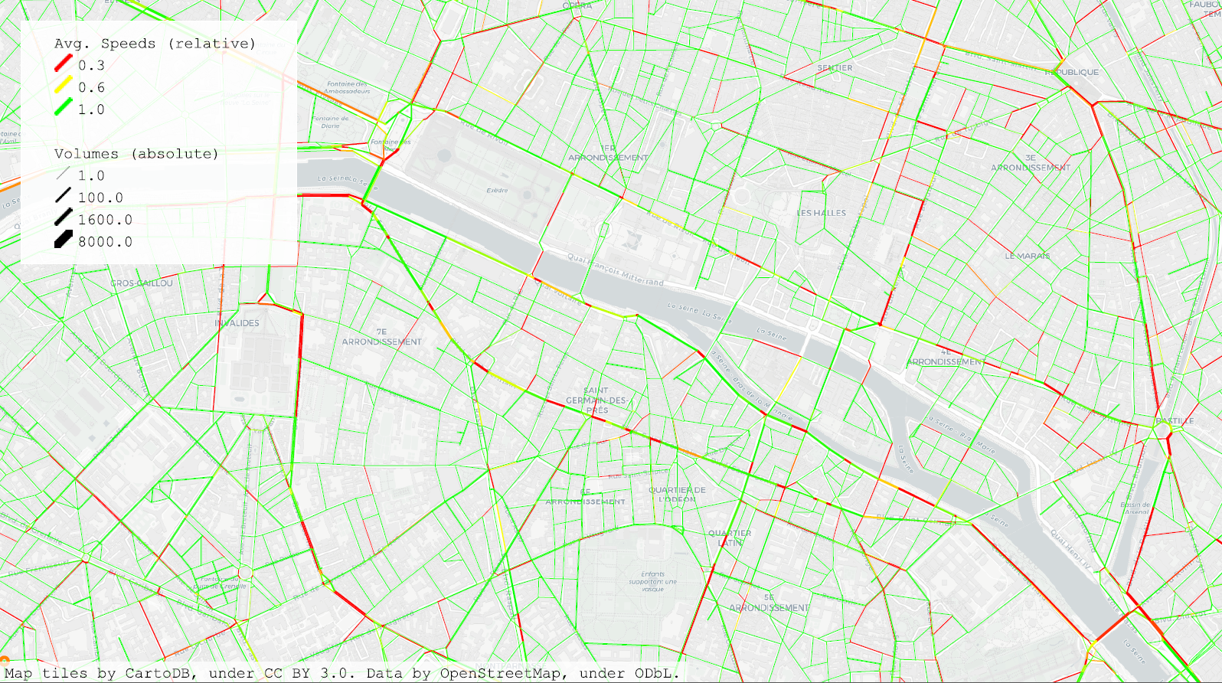

Source: Author

Figure 8: Traffic Volume Visualization under “Flexible Departure” Scenario

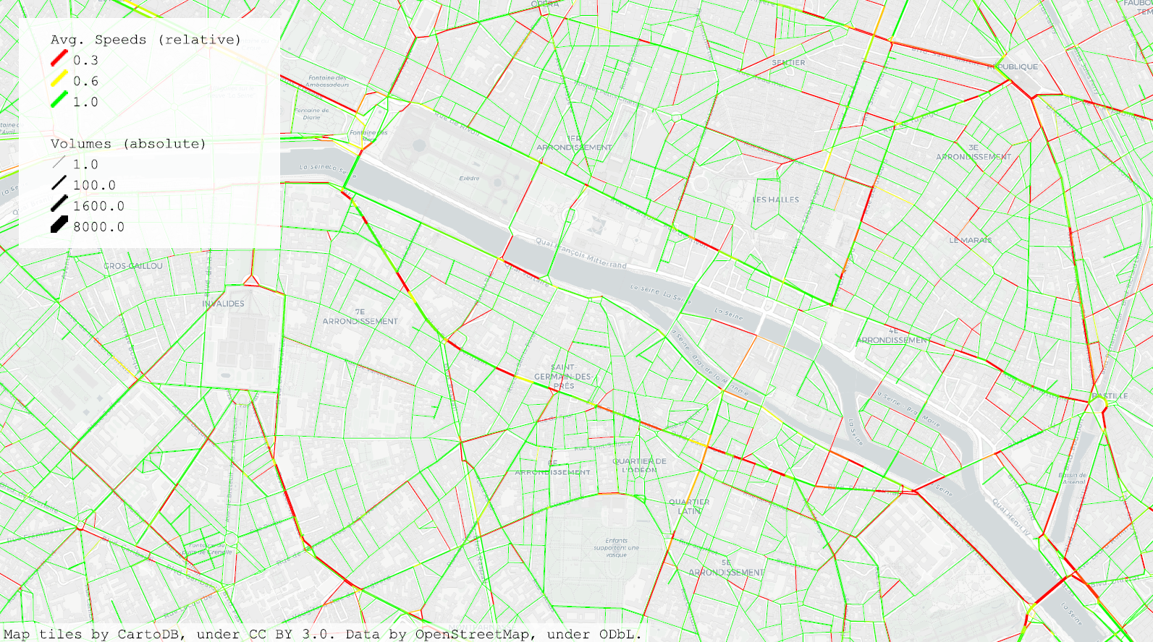

Source: Author

The link volume distribution during morning and afternoon peak hours are shown in Figure 9 and Figure 10.

Both scenarios with closure of route decrease the link volume around the area. One possible explanation is that due to route closure some other nearby links are not as convenient as before and some travelers choose another route outside of this area.

Similar to the change of agents’ travel time, during morning peak hours under “Flexible Departure” Scenario, the traffic volume is higher than that under “Link Closure” scenarios. One possible reason is that some people switch their travel time to 7 a.m. to 8.a.m. to reach a higher score.

Figure 9: Link Volume Distribution under 3 Scenarios (Morning Peak)

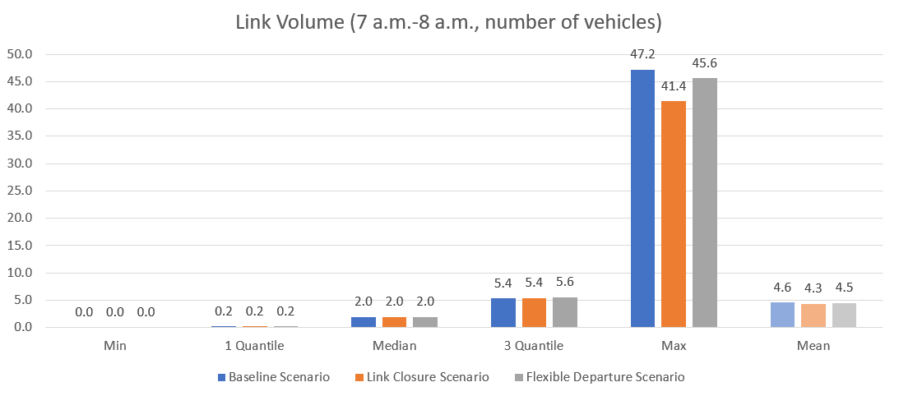

Source: Author

Figure 10: Link Volume Distribution under 3 Scenarios (Afternoon Peak)

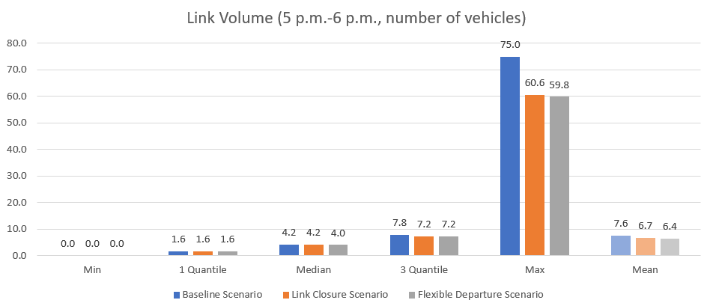

Source: Author

## Emission

Emission based on volume.

# Conclusion and Improvements

## Conclusion

To sum up, we can draw the conclusion that implementing the policy will increase travelers’ travel time and lower their travel utility. During morning peak hour from 7 a.m.to 8 a.m., a flexible departure time even almost double people’s traveling time.

For the neighborhood, the implementation of the policy decreases the traffic volume and thus increase the local walking and cycling quality.

## Limitations

One limitation of this project is that only car operation is considered, which indicates people who drive cars wouldn’t change their mode choice after the implementation of the policy. However, in real life people also compare the utility among transport modes.

Another limitation is that…

## Future Work

One future improvement could be providing different mode options for travelers. How pedestrians and bicyclers would react to the policy is also of great interest.

The impact of different policy could also be simulated using MATSim. One possible policy would be limitation of using roads at different times of a day based on the demand of tidal flow.

What still can be done in the future is…

# References

GoogleMap. (2019, Jan 9). Retrieved from GoogleMap: https://www.google.com/maps

ParisInsidersGuide. (2019, Jan 19). Retrieved from Paris Insiders Guild: https://www.parisinsidersguide.com/paris-arrondissements.html